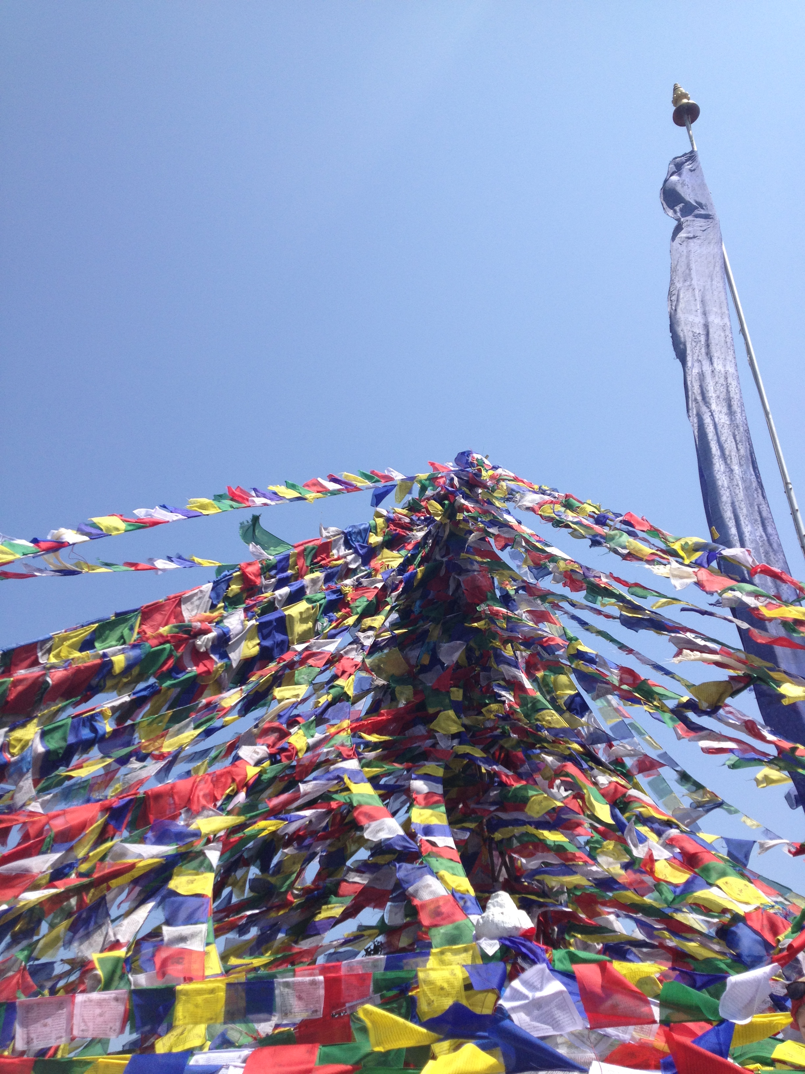**DIGGING DEEP**

**A commuiity ceilidh in support of**

**Nepal earthquake relief**

***Share trekking tales or kick up your heels & dance;***

***whatever you do, come on out and care!***

**Saturday, May 23rd**

**7-11 p.m.**

**Sutherland Secondary School**

**1860 Sutherland Ave, North Vancouver**

*Family-friendly fun featuring stellar bands*

*playing everything from Celtic to Rock:*

*North Shore Celtic Ensemble,*

*Mark James Fortin Trio*

*& more!*

No-host bar and nibblies

Child-minding, door prizes, silent auction, displays

Entrance by donation: minimum $10/person (children under 12 free)

***For information, donations or to book your table, please email:***

[***bsheffield@sd44.ca***](mailto:bsheffield@sd44.ca)

***All proceeds to be donated to Canadian Red Cross/Nepal***